Little Book Of Modelling

**Modelling in Everyday Life**

Modeling solves real-world problems safely and efficiently too. It is a very powerful visualization, planning, and strategic tool in different areas of research and development.

Modelling has come a long way in recent years and as computers are becoming more powerful, the variety of things that they can imitate is becoming larger, and the accuracy of the simulations is better. Modelling and simulations provide an important method of analysis which is easily verified, communicated, and understood.



Nowadays, modelling is very prominent in different industries due to the complexity of modern industrial processes. It plays an important role in revolutionising many industries, mainly the car industry, aerospace industry, in engineering, robotics etc.

In the car industry, modeling enables automakers to create a digital representation that mimics the behavior of a manufacturing system. Modeling helps to identify any problems or obstacles, improve the existing system or propose new models.

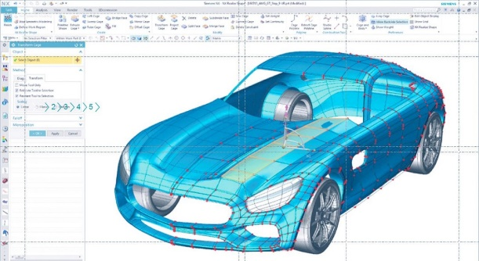

*Design and simulation of cars in a fully virtual environment*

In aircraft industry modelling gives the capability to analyze composite structures in fine detail, layer by layer. It also helps us to craft physical components and optimise the aerodynamic performance of the airframe. With these capabilities we can predict the problems that can cause failures in planes before we even build the first prototype for testing.

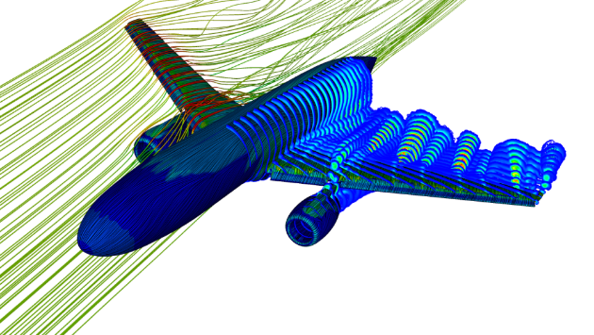

*Airplane takeoff simulation*

Modelling is also used very much from architects and engineers. The support from modelling starts in early phases and it allows us to take into account a wide range of criteria, such as layout, position and the landscape of a construction. In engineering, virtual representations can be used to idealize structural geometrical configurations.

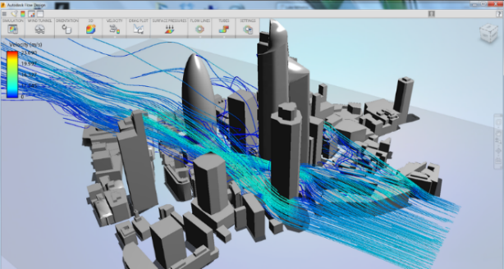

*Simulation in architecture, engineering, and construction*

Modelling and simulation have also a very important role in robotics. Robotic simulations with software tools are a great way to reduce time, cost, and errors for robotic systems. This allows robot programs to be prepared in advance and it also increases profitability by letting training, programming, optimization, and troubleshooting be accomplished without disturbing production.

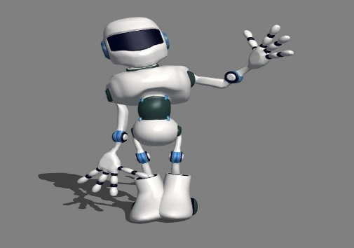

*Simulation in robotics*

**Molecular Modelling**

Modeling is a tool for doing chemistry. In chemistry it is a combination of science and art that study molecular structure and function by using computational technique to generate a realistic model of molecule. A model is a three-dimensional representation of a proposed structure, typically on a smaller scale than the original.

*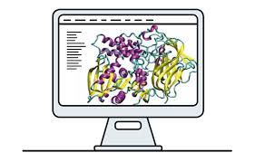 Molecular modelling and computer simulation*

In chemistry models are essential as it is very important to researchers see an accurate model of a molecule's shape when they are solving a problem. Molecular modeling is easy to perform with currently available software, but the difficulty lies in getting the right model and properly interpreting what comes out of them.

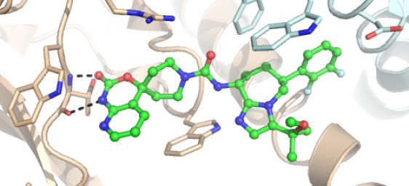

*Molecular modelling of chemical structures*

Molecular modeling should not replace experimental chemistry!

The objectives of chemistry are not changed by molecular modeling. Modelling just helps us learn how to make things (synthesis), how to figure out what things are made of (analysis) and the “rules” that describe chemical behavior.

Molecular modeling is a multi-step process followed by these steps:

1. Interpret Problem

2. Build Models

3. Run Calculations

4. Analyze Data

Predicting chemical properties using a first principles approach at the atomic scale is a theoretical and computational challenge. That means that molecular modelling is based on the development of theoretical and computational methodologies while the basic computational technique to perform molecular modelling is simulation.

The computational approach that is used in molecular modeling includes molecular mechanic, quantum mechanics, and molecular simulation.

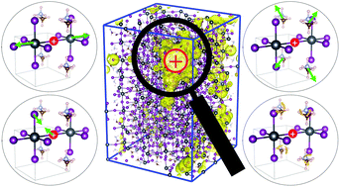

*Molecular mechanical analysis*

Theoretical and Computational chemistry

A scientific theory is an explanation of how things develop and how they work. Theories are not speculative, they are always based on ideas that are well-supported by experimental evidence.

Computational chemistry uses methods of theoretical chemistry that are incorporated into computer programs to assist in solving chemical problems. It usually uses quantum mechanics and thermodynamics to study the fundamental properties of atoms, molecules, and chemical reactions.

*Computational chemistry, a virtual reality*

The computational chemistry programs allow scientists to generate and present molecular data including:

Geometries - bond lengths, bond angles, torsion angles

Energies - heat of formation, activation energy

Properties - volumes, surface areas, diffusion, viscosity

Quantum mechanics is used by computational chemistry to accurately predict chemical and physical properties of molecules and materials.

It describes the energy of a molecule in terms of interactions among nuclei and electrons as given by the Schrödinger equation.

The Schrödinger equation is a linear partial differential equation that describes the wave function or state function of a quantum-mechanical system.

Schrödinger equation

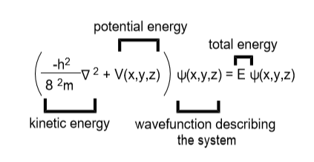

While the Schrödinger equation is easy to write down for many-electron atoms and molecules, it is impossible to solve. Therefore approximations are needed, e.g assume that nuclei don’t move, “Born-Oppenheimer Approximation”

Density Functional Theory

Molecular modeling is primarily a tool for calculating the energy of a given molecular structure. Thus, the first step in designing a molecular modeling investigation is to define the problem as one involving a structure-energy relationship. A potential energy surface connects reactants to products via a transition state.

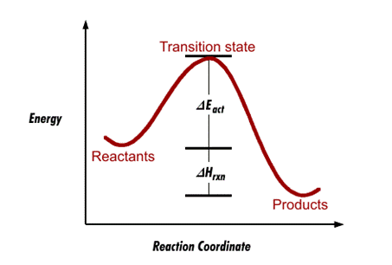Reaction Coordinate Diagram

The maximum peak in the graph corresponds to a transition state structure and represents the maximum energy needed to go from reactants to products. The minimum peaks in the graph correspond to equilibrium structures and give us information on the stabilities of reactants and products.

**Applications of Modelling**

Nowadays modeling techniques are applied in the fields of compound synthesis (conformational analysis and reaction planning), drug discovery (virtual screening), activity rationalization (docking and molecular dynamics simulations), and lead optimization including the prediction of antitarget effects.

By modelling materials at the atomic scale we can now supply fundamental insights into how materials perform in various technologies, ranging from electronics to solar power.

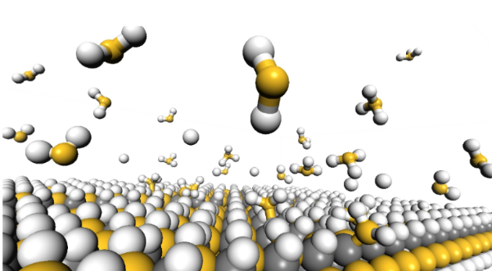

*Surface reactions during plasma-enhanced deposition of silicon carbide.*

Molecular modeling has become a key and elemental tool in medicine in the drug design process. Through modelling now we can investigate, explain, and predict the properties of small organic molecules as potential drug candidates.

Nowadays modelling is conceded as a tool that can save the pharmaceutical industry significant portions of the cost of developing new therapeutics.

*Molecular modelling in drug de*s*ign* 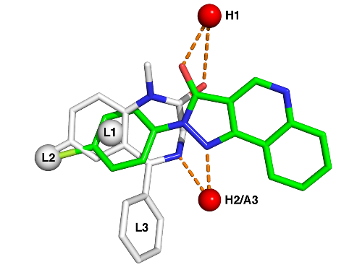

Modelling methodologies require constant experimental feedback from medicinal chemistry and biological experiments to validate the results and to further improve methods.

 *Chemistry lab work*